What is Core ML and how does it work?

Overview
Core ML is a Machine Learning (ML) API (Application Programming Interface) created by Apple to provide developers an easier way to incorporate machine learning training models into their iOS applications. Core ML is built onto of two lower level APIs also built by Apple: Accelerate and Metal. They provide high-performance matrix multiplications and math functions which are optimized for Apple’s chips and processors. Core ML provides methods for image analysis (Vision), natural language processing (Natural Language) and GameplayKit for evaluating learned decision trees. The Graduate School project will use the Vision methods in the application to tag and compare images for similar patterns to match and classify the images. We will be uploading a number of different images and training a model to create a Core ML file that then can be loaded and used by the application.

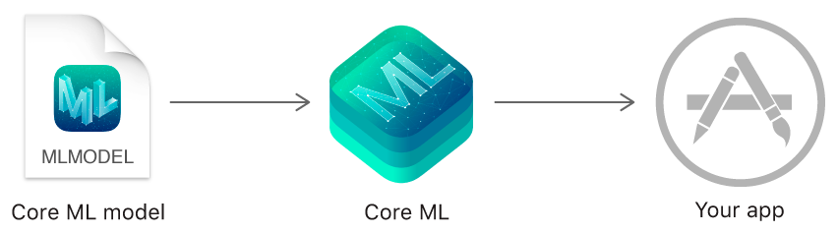

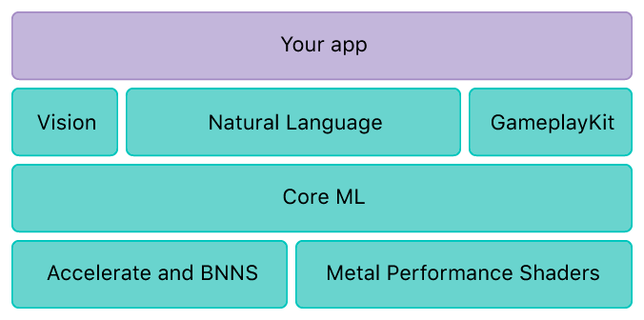

Technical Details
The Vision portion of Core ML allows the developers to do many different machine learning functions like Face Detection, Barcode Detection, Text Detection in an image and other features like Training a model or classifying images with tags with the appropriate percentage matches.

Training a Model
There are several tools that can be used to create a Core ML model including products from Python, Microsoft, Amazon and Apple provides a Create ML tool that can be run in the Xcode editor.

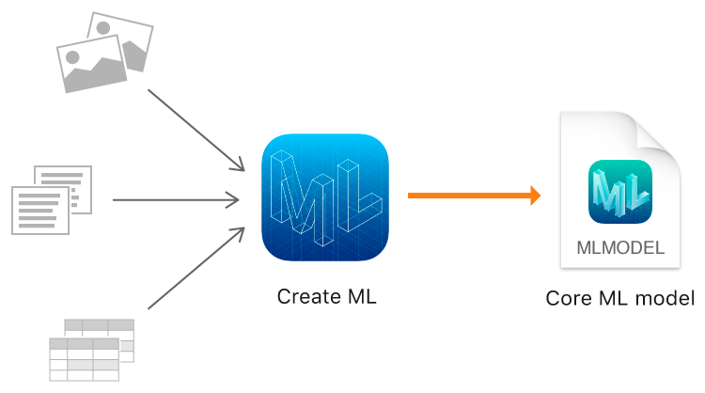

References
https://developer.apple.com/documentation/coreml
https://developer.apple.com/documentation/vision
https://developer.apple.com/documentation/createml
https://pypi.org/project/coremltools/

